Discover the taste of adventure at TOUR SALON 2021
In September, MTP Poznań Expo will become the Mecca of travellers. And this is
thanks to the TOUR SALON fair held on September 24-26 and the accompanying CARAVANS SALON POLAND fair and the Traces of Dreams Travel Festival.
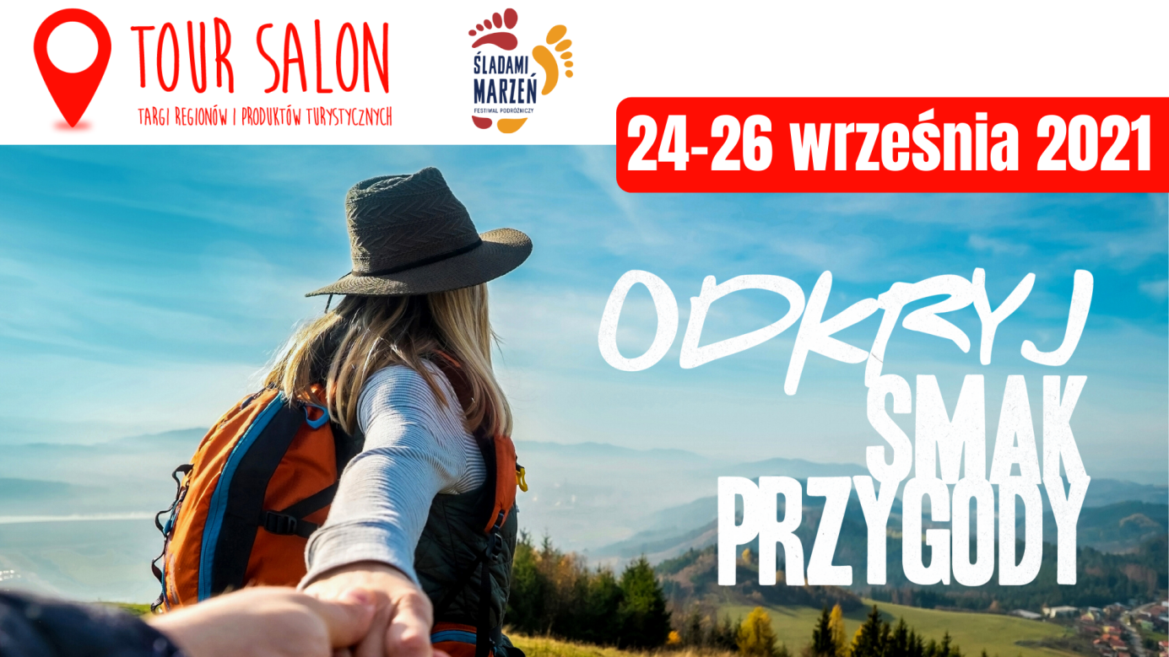
This year’s edition of the fair will be held under the motto “Discover the taste of adventure.” These three words perfectly sum up the value of the exhibition, which this year will include not only the presentation of regions, cities, municipalities and companies offering services in the field of tourism, but also an extensive exhibition of motorhomes and caravans as part of the CARAVANS SALON.
Travel Giants
The heart of the fair will be, as every year, the fair scene, this year shared by TOUR SALON and CARAVANS SALON. The invited guests who will appear on it are undoubtedly “Travel Giants” − eager to take up travel challenges and determined to make their dreams about distant and
short trips come true. This noble group will include, among others Łukasz Supergan − a master of long-distance expeditions, who this winter made the winter crossing of the Polish mountains, through the Polish part of the Sudetes and Carpathians, along the southern border of Poland. This extraordinary journey lasted 49 days and its distance is 1,096 km. This is what you will hear about during TOUR SALON. In turn, Bartek Szaro, who has been writing about his own expeditions for over a decade at www.paragonzpodrozy.pl, will report on the first stage of the “50 rivers” project during the fair. Its aim is to sail and describe the 50 most interesting sections of Polish rivers in line with the spirit of sustainable development of tourism. It is a real treat for enthusiasts of canoeing trips.
There will also be stories of distant journeys. Marcin Jakub Korzonek will be another member of the Travel Giants group. He will talk about the Kross The Record 2020 project − a lonely journey through the Atacama desert in Chile, struggling with adversity and nature, and an attempt to break the world record
of the height that a cyclist has ridden. The stage will also feature the leaders of the Soloists Travellers’ Club − Monika Ścibor will take the fair guests to the African continent, and Hanna Zieleźnik-Rybak will talk about her great love − the Azores archipelago.
Caravanning enthusiasts will also appear on the fair stage. There will be, among others Kasia and Łukasz − the creators of the PodróżoVanie project, and Zosia and Kuba, i.e. Foxes in Eden, who went for broke, abandoning their current stationary life to pursue their dreams of travelling
and freedom. Aga and Bartek, the authors of the Calluna Trip blog and vlog, will also talk about their passion for travelling in a motorhome.
More information about appearances on the fair stage: https://bit.ly/3jqYYgu
Following Dreams
The fair scene is not the only place that will draw visitors into a whirlwind of travel passion.
In the iconic MTP Poznań Expo Spire, the Traces of Dreams Travel Festival will be held. As many as 16 finalists will compete in the competition for the “Golden Trace”, taking the viewers on a beautiful trip around the world. The itinerary includes such a distant place as Laos, Burma, Venezuela, Namibia, the United States, Canada and the Raja Ampa Archipelago, but you will also be able to listen to presentations discovering the beauty of our country and listen to, for example, Dorota Chojnowska discovering the treasures of Poland or Katarzyna Augustyn, who will share impressions of the Main Beskid Trail.
Detailed program of speeches: https://bit.ly/3gMluhU
Caravanning Rally, Retro and Hand Made Zones
The program of the fair will be complemented by the 12th National Caravanning Rally, held
as part of the CARAVANS SALON fair with the participation of teams from all over Poland and abroad. The rally will take place on the MTP Poznań Expo fairgrounds at Mark Square and in the car parks adjacent to the exhibition halls.
Moreover, in addition to the exhibition, 2 special zones will be available to visitors: the Retro Zone and the Hand Made Zone, which will allow visitors to learn about the history of caravanning on the example of specific models (Retro Zone) and show how you can creatively build your own motorhome (Hand Made Zone).
The weekend of 24-26 September at the MTP Poznań Expo fairgrounds promises to be extremely interesting and will undoubtedly be a strong impulse, even though the summer holidays are over, to plan further, both distant and short expeditions. All the events are available on the basis of a single ticket.

