Poznań, 4 June 2019

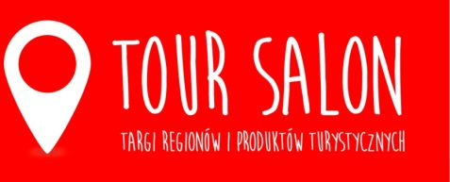

Discover the taste of adventure at TOUR SALON 2020
The 31st edition of the TOUR SALON Fair of Regions and Tourist Products will be held on 14-16 February 2020 in Poznań. The event will be promoted by the motto "Discover the taste of adventure." What does it mean?
Poles like to travel. They do it more and more often, on various occasions. They visit Polish regions, but also decide to go on trips outside of the country. The travelling trend is developing, and inspiration to travel is provided by influencers in this category, as well as events dedicated to travelling. This is the objective of TOUR SALON organizers.
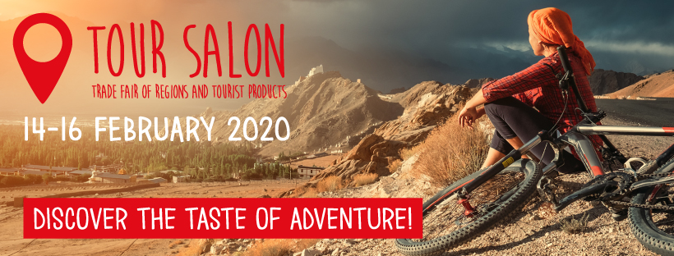
TOUR SALON is to be a place where adventure begins, and where you can prepare for it. Therefore, a wide range of companies and institutions is invited to cooperate, including regional tourist organizations and local government units, representatives of tourist attractions such as theme parks, museums, zoological gardens, tourist trails, tour operators and travel agencies, hotels, wellness & SPA centres, health resorts, sanatoriums, organizers of thematic trips, as well as manufacturers of tourist equipment.
We want the exhibition to be comprehensive, to show the direction for our guests' travels, and in particular to encourage them to explore interesting places in our country, and to enable the visitors to learn the trends in camping equipment or outdoor clothing – explains Filip Bittner, Product Group Director.
Next year's edition of TOUR SALON will be held under the motto "Discover the taste of adventure." It is the quintessence of plans for the event. TOUR SALON is to inspire. Therefore, as organizers emphasize, in 2020 there will be numerous meetings with famous travellers organized, who, with their colourful stories, will take fair visitors to amazing places. The word "taste" in is not coincidental in this case.
In this way, we want to emphasize that during the Fair special attention will be paid to culinary tourism. More and more tourists decide on their travel destinations on the basis of taste experiences offered by the region. Together with regions, we want to encourage everyone to this style of exploring Polish and foreign regions. We want to talk to experts and invited travellers about culinary travels and effective use of the trend. Many cities have bloggers as their ambassadors. We hope that we will also invite them to cooperate. – informs Filip Bittner.
TOUR SALON will be held in mid-February next year. For more information visit: www.tour-salon.pl

Media contact:
Katarzyna Świderska, e-mail: katarzyna.swiderska@mtp.pl, phone no.: 691 033 850

