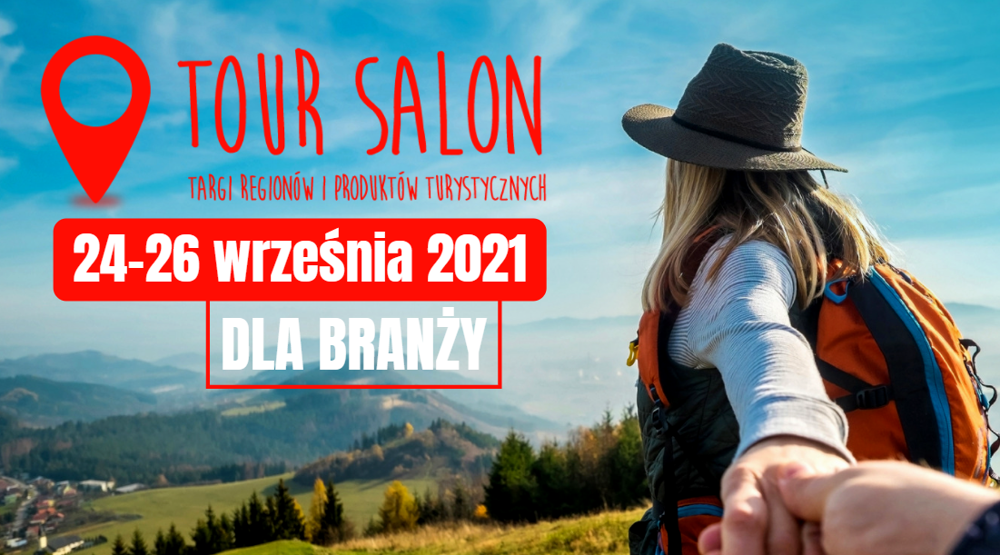
TOUR SALON 2021 − industry meeting
On September 24-26 this year, on the premises of MTP Poznan Expo, the
21nd edition of the TOUR SALON Trade Fair of Regions and Tourist Products will be held. The program includes events for representatives of the tourism industry.
This year’s edition of the event will be created by over 60 exhibitors − regions, cities, municipalities, travel agencies, providers of transport services in tourism. It will be complemented by an exhibition of motorhomes as part of the CARAVANS SALON POLAND fair, which will be held simultaneously. Thus, the entire exhibition will occupy more than two exhibition halls.

Industry meetings
The program of events includes mainly travel lectures, but the organisers did not forget about representatives of the industry, for whom interesting meetings were prepared on
Friday, September 24:

Panel: Individual and family tourism in times of pandemic restrictions
September 24, 2021 at 1 p.m.

During the meeting, the idea of culinary tourism and examples of culinary routes available in the world and in Poland will be presented. Participants will be able to learn about such routes as: - “Tastes of Lower Silesia”; “Western Masuria behind the scenes” and “Tastes of the Poznań District”. Speakers will also talk about local products in the context of tradition, health, mission, education and the important role of the family in shaping consumer awareness. The event is co-organised by: Grupa MTP − TOUR SALON Fair; Polish Tourist Organisation; Lower Silesian Tourist Organisation; West Masurian Local Tourist Organisation; Landbrand − Development of Culinary Tourism and the Poznań District. Free admission as part of the invitation to the fair.

Bulgaria: year-round tourist destination − presentation
September 24, 2021 at 2:30 p.m.

The event is organised by the Bulgarian Ministry of Tourism through its National Tourist Office in Warsaw and in cooperation with the Embassy of the Republic of Bulgaria in the Republic of Poland. The presentation of Bulgaria at the fair includes a speech by HE Ms Margarita Ganeva, the Plenipotentiary and Extraordinary Ambassador of the Republic of Bulgaria in Poland, and an advertising and information presentation of the National Tourist Representation presenting the tourist opportunities of Bulgaria and promoting the country as an attractive and safe tourist destination.

The speech session will be followed by discussions and asking questions. You will also be able to present your suggestions as to the image of the country and how it is presented on the Polish market, or share suggestions on the possibility of extending cooperation.

Early registration is required for the event >>

Admission for representatives of the tourism industry
As every year, admission for representatives of the tourism industry is free. To receive an invitation to TOUR SALON, you must register in advance at: https://tour-salon.pl/pl/dla-zwiedzajacych/wazne-informacje/bezplatne-zaproszenia-dla-profezjaalistow/

For more information visit: www.tour-salon.pl

